Hollow Crest Sacarament Meeting broadcast
Stake Tech Troy Mace 801-400-3186

Step 1 Setup
- turn on laptop (password = Pioneer47)
- start camera app on laptop full screen
- turn on FH computer
- Start browser on FM computer
- turn on teradek (switch in on the left side)

Step 2 Start Broadcast
- Note that wifi will be turned off so you must use a network connected computer
- In the browser, open http://192.168.108.2/ to the Teradek (bookmarked as VidiU) If by chance the page doesn't open, check the Network | Wired IP address on the teradek
- 10 min or so before Sacrament Meeting starts, push the green icon on the teradek web page. This will turn red 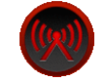to indicate you are broadcasting
- In the browser, open http://mywebcast.churchofjesuschrist.org/highlandutahcentralstake to the list of sacrament meetings (bookmarked as HighlandCentralSacramentMeeetings)
- Select your meeting and view that the broadcast is working. Note that you can change the buffer seconds in the lower right corner of the video to 30 sec. That way you are only 30 sec behind the actual broadcast. You can check the sound with the external spreakers by the laptop.

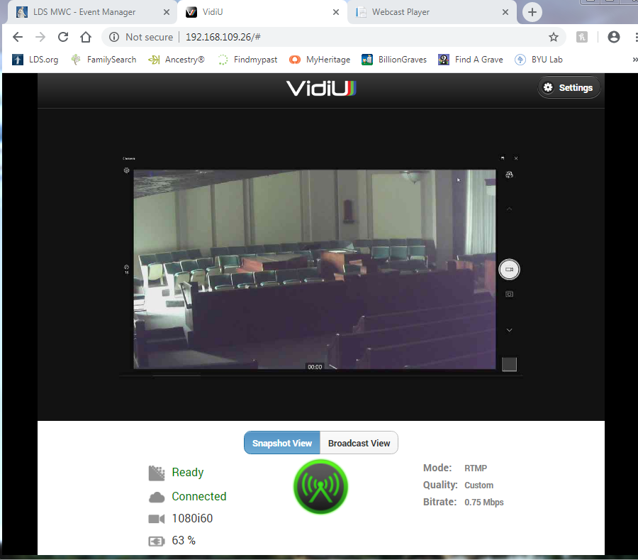
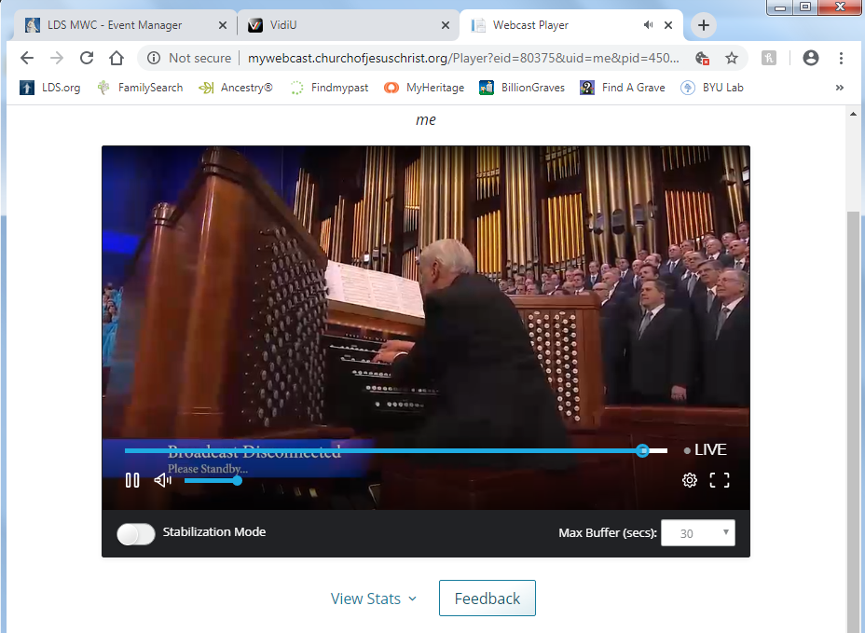

Step 2 End Broadcast
- Select the red Icon on the VidiU web page. The icon will go green again
- Shutdown computer
- Turn off Teradek

